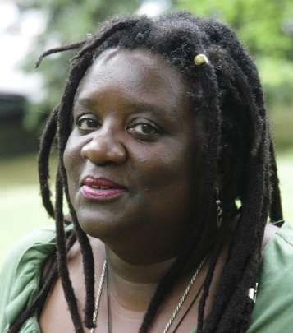
VIENNA CARROLL
HARLEM FIELD RECORDINGS

“…politically-charged reinventions of classic blues and gospel themes as well as more traditional numbers and originals which sound like 19th century standards. It’s classic music as you’ve probably never heard it before.”
NEW YORK MUSIC DAILY, March 2020
Vienna Carroll’s new CD Harlem Field Recordings is a collection of Spirituals, work songs and blues with a Serious Groove like you haven’t heard before. It grew out of her project Folk First: Black Roots Music celebrating early Black music and its influence on the music of today. Vienna draws unexpected folkloric connections with contemporary artists, and NYC subway candy men, noting specific historical moments in African American history.
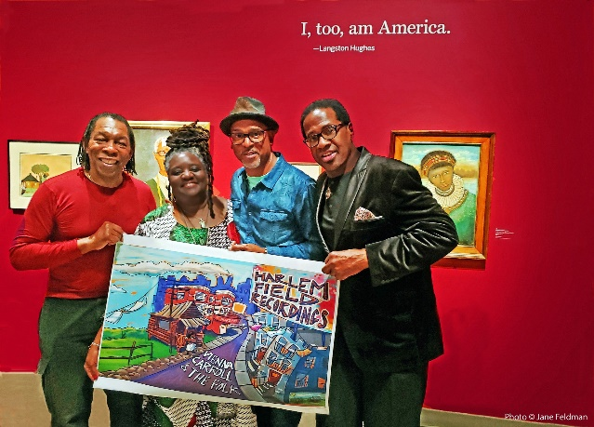
It’s the fire in her belly that lights up the fire in your soul. Vienna Carroll's folksy blues and soulful funk take you back to church, back to the roots. The passion in her voice and her masterful storytelling fill a room, draw you in and hold you close. Vienna's larger-than-life performances channel influences from Ray Charles, Dinah Washington and her great-grandmother Susie Stokes' Wheatfield Church of the Living God.

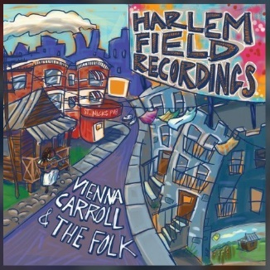

Track Listing
1. Strawberries & Glory 2:54
2. You Better Mind 2:57
3. Come On In My Kitchen 3:07
4. No Mo Freedom 1:43
5. Dangerous Blues & Do Berta 4:15
6. Let’s Go Down to the River to Pray 2:26
7. I Just Wanna Make Love to You 4:41
8. All the Pretty Little Horses 3:18
9.Make the Devil Leave Me Alone 2:21
10. Grinnin In Yo Face 2:41
11. Singin Wid A Sword In Ma Han 3:14

Harlem Field Recordings features Vienna on vocals, Stanley Banks (George Benson) on bass, Washboard XT aka Newman Taylor Baker (Joe Henderson, McCoy Tyner, Henry Grimes) on washboard, Keith Johnston (Lisa Lisa and Cult Jam, Jon Hendricks) on guitar, and guests Nioka Workman (Anthony Braxton, David Murray) on cello, Melanie Dyer (Joe Bonner, Reggie Workman) on viola, and Henrique Prince (Ebony Hillbillies, Sun Ra Arkestra) on fiddleviolin.

Contact:
Vienna Carroll
viennacarrollmusic@gmail.com
646-763-4587

viennacarrollmusic.com

Facebook: viennacarrollmusic
Instagram: viennacarroll

Other Projects: |viennacarroll.com |shallowbrown.com |singinwidasword.com |undergroundrailroadfestival.org

