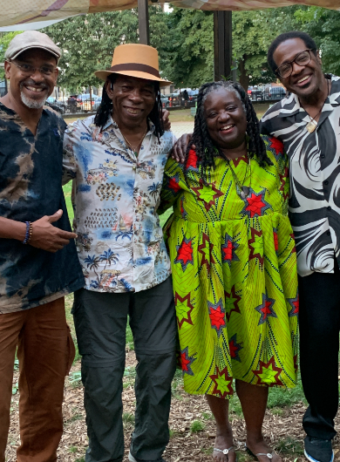
Vienna Carroll & The Folk
debut the single
I KNOW I BEEN CHANGED

“Activates the Soul, Warms the Spirit and
Makes You Wanna Dance!”
A Song of Liberation

Listen Here
"politically-charged reinventions of classic blues and gospel themes... It’s classic music as you’ve probably never heard it before." New York Music Daily

I Know I Been Changed is Vienna Carroll’s new single from her upcoming CD Harlem: Afro Future Roots, a special collection of Spirituals honoring the 31 shackled-and-chained ancestors who freed themselves from slavery. In 1826 on a boat from Baltimore to deep south death, they threw their captors overboard and escaped to freedom.

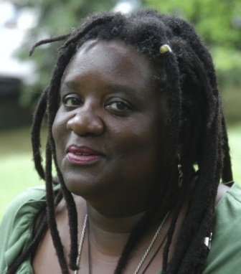
Bio
Vienna’s rich soulful sound takes you back to her first music love, the Black church. She shares forgotten stories of Black heroes and presents those old songs through a modern lens to make: Afro-Future Roots Music.
“Vienna Carroll...a unique story of America, sung by an incredible voice. Simply stunning.”
Woody Lewis, musician

She is joined by her groovetastic band, The Folk: Stanley Banks (George Benson) on bass; Washboard XT/Newman Taylor Baker (Matthew Shipp, Ebony Hillbillies, Henry Grimes) on washboard; and Keith Johnston (Lisa Lisa and Cult Jam, Jon Hendricks) on guitar.

Vienna learned music from the Black Ladies of her youth including her fearsome great grandmother who played guitar to Grand Ole Opry radio on Saturday nights but only proper Pentecostal chords on Sundays. Vienna formalized her musical studies at Yale University with a BA in African American Studies.

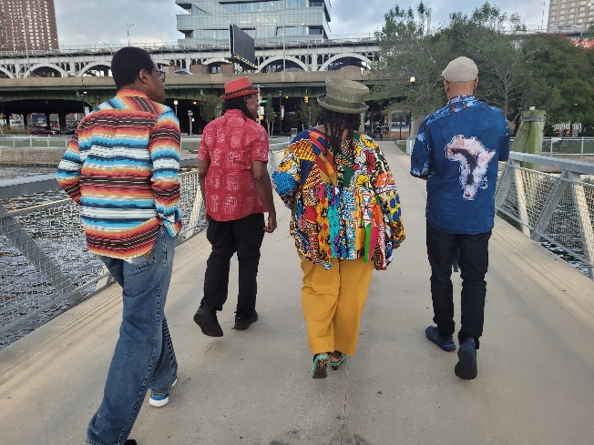

“Hauntingly mesmerizing – an ancestral heartbeat ushers in future fearlessness”
Kath Saxby, fan

Listen Here

Contact: Vienna Carroll
Email: viennacarrollmusic@gmail.com
Phone: 646.763.4587

Website: viennacarrollmusic.com

Instagram: @viennacarroll
Facebook: facebook.com/viennacarrollmusic

Other Projects: |viennacarroll.com | shallowbrown.com | singinwidasword.com | undergroundrailroadfestival.org
Photo: Jane Feldman

