FOR IMMEDIATE RELEASE:
Vienna Carroll and The Folk to Release the Afro-Future Roots Single of
“Swing Low Sweet Chariot” on February 10, 2023
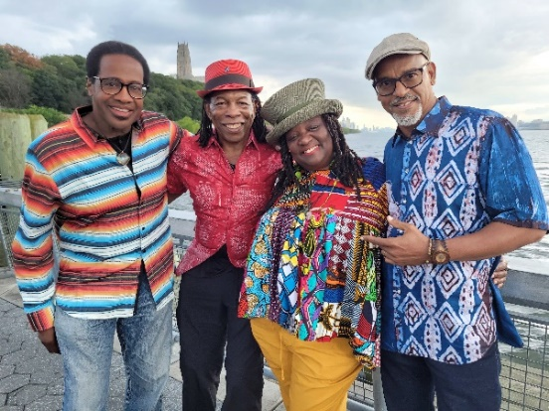
“A Winning Honesty…powerfully emotional music.” Jazz Lives
DISCO link
NEW YORK, NY, January 31, 2023 – “Swing Low Sweet Chariot” is Vienna Carroll & The Folk’s new single from their upcoming CD, Harlem: Afro Future Roots, a special collection of Spirituals honoring 31 enslaved Africans headed from Baltimore to certain deep south death in 1826. Instead, they took their future in their own hands, threw their captors overboard and escaped to freedom.
Vienna Carroll and the Folk will be at the Metropolitan Museum of Art NYC, to celebrate the Met’s Seneca Village exhibit with their Afro-Future Roots music on February 24 and 25th, 6-8:30pm, Petrie Court Cafe.
“Activates the Soul, Warms the Spirit and Makes You Wanna Dance!” Keith Johnston, Composer & Guitar
Vienna’s rich soulful sound takes you back to her first music love, the Black church. She shares forgotten stories of Black heroes and presents Spirituals and work songs through a modern lens. She calls it Afro-Future Roots Music.
“Vienna Carroll...a unique story of America, sung by an incredible voice. Simply stunning.” Woody Lewis, composer
Vienna is joined by her groovetastic band, The Folk: Stanley Banks (George Benson, Esther Phillips) on bass; Washboard XT/Newman Taylor Baker (Matthew Shipp, Ebony Hillbillies, Henry Grimes) on washboard; and Keith Johnston (Jon Hendricks, Lisa Lisa and Cult Jam) on guitar.
“We freed ourselves from slavery. We are the center of our own freedom stories. The Spirituals are our liberation songs,” says Carroll.
The unique sound of “Swing Low Sweet Chariot” was crafted by Keith and Vienna during the award-winning run of “Singin Wid A Sword In Ma Han,” Vienna’s musical docu-drama about a family escaping slavery. This was followed by Vienna’s first album of the same name, a reprise of Spirituals from the play, in collaboration with Washboard XT. The CD Harlem Field Recordings, recorded with the Folk and released in 2020, celebrates early Black music and its influence on the music of today.
“politically-charged reinventions of classic blues and gospel themes as well as more traditional numbers … which sound like 19th century standards. It’s classic music as you’ve probably never heard it before” – delarue, New York Music Daily
“Swing Low Sweet Chariot” was recorded at Shelter Island Sound Studio (Bobby McFerrin, Bob Dylan, Suzanne Vega), and mastered at Jon Gordon Music Production (Madonna, Suzanne Vega).
“Haunting – an ancestral heartbeat ushers in future fearlessness.” Kath Saxby, writer
DISCO link
“Swing Low Sweet Chariot,” to be released on Friday, February 10, 2023, will be available on viennacarrollmusic.com, Spotify, Bandcamp and Apple Music.
For more information visit www.viennacarrollmusic.com
###
Media and Interviews: viennacarrollmusic@gmail.com 646.763.4587
Website | Press Kit | Instagram | Facebook | Bandcamp

